AIM ORGANIZATION  FAISALABAD, PAKISTAN  AIM IS REGISTERED WITH THE GOVERNMENT OF PAKISTAN SINCE 1992  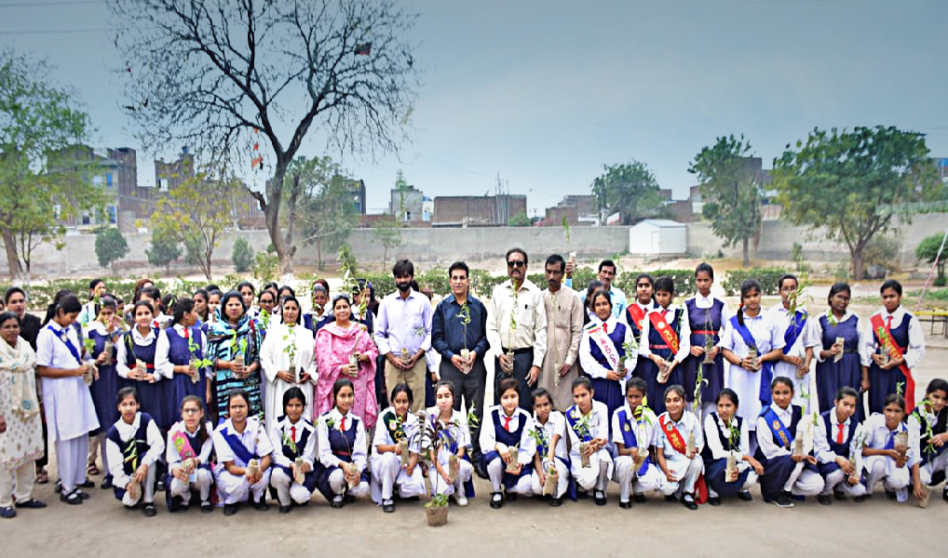  NON—PROFIT WELFARE ORGANIZATION |  | HEA | LTH |  | EDUCATION |  | WOMEN EMPOWERMENT |  |  | SKILL DEVELOPEMENT |  |  | WORK | WITH |  | US | CONTRIBUTE WITH US
 |  | HOME ABOUT US PROJECTS PHOTOS VIDEOS EVENTS NEWSLETTER |  |  |  |  |  |  |  |  |  |  |  |  |  |  | SEARCH
COMMUNITY DEVELOPMENT FOR
SUSTAINABILITY
AIM was Wounded in 1991 by ó persons; most of them keep social backgrounds and fame. These six persons were from the same target area where AIM first started its initiative. They worked with the community to form an organization that will help them and solves their problems with the help o( awareness and education. With extensive exercise, IDENTITY, MERGE AND ACTION was formed, and its objectives and working methodology were settled. The basic purpose behind the formation of this organization was to help needy communities sustain their livelihood and have bright futures. AIM believes in the empowerment of women, development of the backward communities; helping the poor people fight against sickness, and taking action against illiteracy through educating the children to whom access to education is abandoned. Support the poor farmers with their livestock and apricultural lands.
READ FULL DATE: 10-07-23
STRENGTHENING COMMUNITIES FROM THE GRASSROOTS LEVEL
A Passionate Educationist founded the AIM organization in 1991, inspired to empower people from the underprivileged communities of Faisalabad. Belonging to a minority group himself, he realized the importance of human development for creating upward socio-economic mobility within deprived communities. He started the organization with five other like-minded individuals who focused on providing health care, education, and skill development for girls and women in Pakistan.

He focused on ensuring early childhood education, Improved and accessible healthcare programs & and empowering young girls and women through skill-building activities/programs. His lasting legacy has been to empower families while instilling awareness about health issues and inspiring everyone to make efforts towards stabilizing livelihoods and alleviating poverty through mutual efforts.

His work has touched many lives directly or indirectly over the last three decades since its establishment —furthering his legacy as an esteemed educationalist who believed strongly in human development through learning.
 |  |  |  | GYNAE CENTER  PATIENTS |  |  | 35,870
GYNAE CENTER  PATIENTS | 35,870 |  |  |  |  |  |  |  | GYNAE CENTER  PATIENTS 35,870 |  |  |  |  |  |  | GYNAE CENTER  PATIENTS 35,870
EYE HOSPITAL  PATIENTS | 35,870 |  |  | EYE HOSPITAL  PATIENTS |  |  | 35,870 |  | EYE HOSPITAL  PATIENTS 35,870 |  |  |  |  |  |  | EYE HOSPITAL  PATIENTS 35,870
TB CENTER  PATIENTS | 35,870 |  |  | TB CENTER  PATIENTS |  |  | 35,870 |  | TB CENTER  PATIENTS 35,870 |  |  |  |  |  |  | TB CENTER  PATIENTS 35,870
COMMUNITY DEVELOPMENT FOR SUSTAINABILITY
AIM was Wounded in 1991 by ó persons; most of
them keep social backprounds and fame. These six persons were from the same target area where AIM first started its initiative. They worked with the community to form an organization that will help them and solves their problems with the help of awareness and education. With extensive exercise, IDENTITY, MERGE AND ACTION was formed, and its objectives and working methodology were settled. The basic purpose behind the formation of this organization was to help needy communities sustain their livelihood and have bright farmers with their livestock and apricultural lands.

DATE: 10-07-23
@AII Rights Reserved Since 1992, Info@aimngo.pk — aimngo.pk

AIM ORGANIZATION
HEALTH | EDUCATION | WOMEN EMPOWERMENT |  | SKILL DEVELOPEMENT |  | WORK WITH US | CONTRIBUTE WITH US
HOME | ABOUT US | PROJECTS | PHOTOS | VIDEOS | EVENTS | NEWSLETTER | SEARCH

FAISALABAD, PAKISTAN
AIM IS REGISTERED WITH THE GOVERNMENT OF PAKISTAN SINCE 1992
NON—PROFIT WELFARE ORGANIZATION

BIO FOUNDER OF AIM
In 1991, a compassionate educationist hailing from a minority background witnessed the numerous hurdles (aced by communities striving (or development. Moved by a deep sense of empathy, he took a momentous leap by resigning from his job and embarking on a mission to create positive change. This led to the founding of AIM, an organization wholeheartedly dedicated to empowering underprivileged communities.

AIM's visionary founder recognized that true empowerment necessitated addressing a multitude of issues hindering progress. With an unwavering commitment to education, healthcare, and skill development, AIM set out to tackle these challenges head-on. Their goal was to provide communities with the necessary tools and support to overcome barriers and achieve sustainable development.

Through AIM's educational initiatives, they aimed to break the cycle of poverty by providing quality education to children and youth. They believed that education was not only a (undamental right but also a powerful catalyst for social transformation.

AIM INTRODUCTION
Welcome to AIM - Identity, Merge, and Action!
AIM is a non-profit, non-governmental organization, established in 1991 with a clear purpose - to improve the living standards of the underprivileged community in Pakistan. With a deep-rooted belief in the power of partnerships, we strive to create lasting chanpe through collaborative efforts.
Our organization is driven by three core principles: Identity, Merge, and Action. We believe that understanding and embracing our identity as individuals and as a community is crucial in addressing the challenges we face.
Through partnerships and collaborations, we merge our resources, expertise, and passion to find sustainable solutions to the problems our communities face. We believe that when we come together, we can make a meaningful difference.
But our work doesn't stop at the merging stage. Action is the key to transformation. We translate our shared understanding into practical efforts that directly impact the lives of the underprivileged. From education and healthcare to community development, we are dedicated to creating a better and improved living standard for all.
At AIM, we understand the power of working hand in hand with like-minded organizations, government agencies, individuals, and volunteers who share our vision. Together, we can go further and achieve greater impact.

VISION
To achieve sustainable and self-reliant communities through comprehensive community development initiatives.

MISSION
To empower individuals and communities in Pakistan through information, research, coordination, education, and training.

OBJECTIVES
- Facilitate Self-Identification: Help individuals recognize their unique identities and strengths.
- Transform Unsatisfactory Situations: Enable communities to address and overcome challenging circumstances.
- Training for Development: Provide education and training to empower individuals for personal and community growth.
- Resource Mobilization: Promote the utilization of internal resources for sustainable development.
- Foster Partnerships: Encourage collaboration and merging o( efforts for common interests.

These clear and concise statements outline our focused direction and objectives as an organization.

MESSAGE BY EXECUTIVE SECRETARY
As the current Executive Secretary of AIM, I am incredibly proud of the progress we have made and the impact we have had on the lives of individuals and communities. AIM continues to work tirelessly towards our mission of empowerment and social development.
Currently, AIM is focusing on expanding our skill training programs for youth, with a particular emphasis on providing vocational training and entrepreneurship opportunities. We believe that by equipping young individuals with practical skills and knowledge, we can empower them to create better futures for themselves and their communities.
Additionally, we are increasing our efforts in promoting women's empowerment through various initiatives such as training programs, awareness sessions, and support for income-generating projects. We aim to create an environment where women have equal opportunities, and access to education, healthcare, and resources to thrive and succeed.
Looking ahead, envision AIM growing stronger and more impactful in the coming years. I would like to see AIM become a recognized leader in community development, addressing not only immediate needs but also focusing on long-term solutions. We will continue to collaborate with local communities, government bodies, and other organizations to create sustainable change and uplift the lives of those in need.
Furthermore, we will strive to expand our reach to underserved areas and marginalized communities, ensuring that our programs are accessible to those who need them the most. It is my vision that AIM becomes a catalyst for positive change, fostering an inclusive society where every individual has equal opportunities and the ability to lead a fulfilling life.
Together with our dedicated team and committed supporters, I am confident that we can make a significant difference in the lives of many. AIM will continue working towards our goals,
@All Rights Reserved Since 1 992, Info@aimngo.pk —aimngo.pk

Only two pages were converted.
Please Sign Up to convert the full document.

www.freepdfconvert.com/membership

